**Project 2. Basic Classifier and Regressor**

**Major Tasks:**

1. Learn more about how to utilize data sets and Python libraries;
2. Learn the basics of classifiers and regressors;
3. Improve Python programming and report writing skills.

**Part 1. Classification:**

* 1. Run the example program code and fix any problems you encounter;

Q3.2. classify digit zero and non-zero for the binary classifier, instead five and non-five in the example. Show your results.

Q3.3. What are the performance metrics of binary classifiers and how to interpret them? Use the zero/non-zero example to explain those metrics.

Measuring Accuracy Using Cross-Validatio (“Implementing Cross-Validation”)

Confusion Matrix

Precision and Recall (tradeoff threshold)

The ROC Curve (receiver operating characteristic)

(sensitivity (recall) versus 1 – specificity.)

area under the curve (AUC). Perfect: ROC AUC = 1

Q3.4. What are the differences between these concepts: multi-class, multi-label, and multi-output classification?

multi-class : distinguish between more than two classes

multi-label : outputs multiple binary labels

multi-output: generalization of multilabel classification where each label can be multiclass

* 1. Work through Exercise 1 and 2 in Chapter 3. Answer questions Q3.5.

Q3.5. In Exercise 2, what are the other ways to alter the image data set?

* 1. For ECE450 students: Images may be rotated, shrunk, filtered, noise added, or blurred. Choose another one or two methods to argument the data set and train the classifier again; Report your results.

Rotate. **Results?**

Q3.6. What did you learn most in Part 1 of Project 2?

Basic theoretical concepts of classifier

**Part 2. Regressor:**

2.1. Follow the instructions of chapter 4 in the Hands-on ML book and work through the basic project.

Q4.1. There is some error in the textbook and the error is noted in the notebook file. What is the error? How is pseudoinverse calculated differently from the Normal Equation?

the first releases of the book implied that the LinearRegression class was based on the Normal Equation. This was an error. It is based on the pseudoinverse, which ultimately relies on the SVD matrix decomposition of **𝐗**. Its time complexity is O(n2) and it works even when m<n or when some features are linear combinations of other features (in these cases, XTX is not invertible so the Normal Equation fails), see [issue #184](https://github.com/ageron/handson-ml/issues/184) for more details.

(However, this does not change the rest of the description of the LinearRegression class, in particular, it is based on an **analytical solution**, it does **not scale well** with the number of features, it scales linearly with the number of instances, all the data must fit in memory, it does **not require feature scaling** and the order of the instances in the training set does not matter.)

2.2. There are three gradient descent algorithms in the example: batch gradient descent, stochastic gradient descent, and mini-batch gradient descent. When you work through these examples, pay close attention to the results. You will need those results to be compared with the ones you get in Step 2.3.

2.3 Change the training data set in cell [2] from *X = 2 * np.random.rand(100, 1)* to *X = 4 * np.random.rand(100, 1).* Restart the kernel to run through the program. Change the corresponding plt.axis parameters to plot the correct figures.

Q4.2. Do you observe any difference in the results when changing the inputs? If so, include them in your report. Explain why they are different.

Theta[1] becomes bigger. Don’t know why

Notice BGD’s result is always the same as normal equation, but not SGD and mini-BGD. Coincidence?

Q4.4. In the stochastic gradient descent algorithm, how is the learning rate eta changed? Try to plot the value eta vs. the iteration index (epoch*m+i) for the epoch and i values used in the example.

In a exponential way –

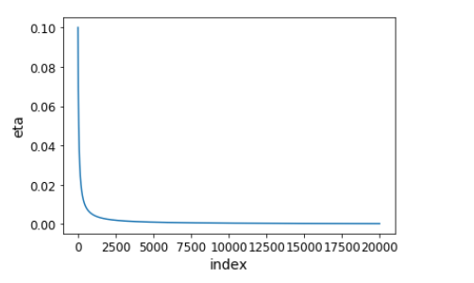

Q4.5. In the mini-batch gradient descent algorithm, how is the results different from the original example? Do you observe any problems? If so, how to fix the problems?

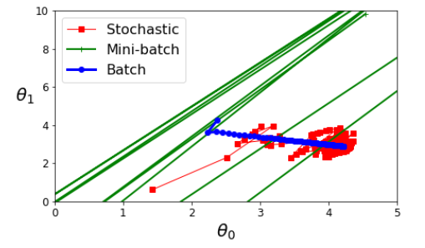

Don’t seem to convergence when iteration is 50

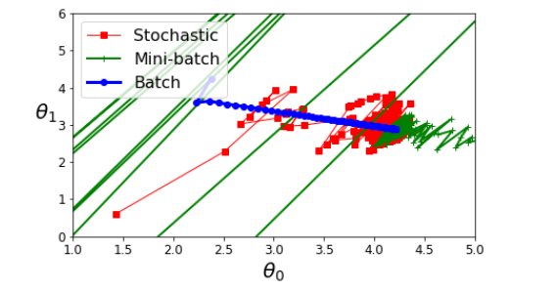

Seem to convergence when iteration is 300

2.4. In the polynomial regression example, change the training data to *X = 10 * np.random.rand(m, 1) – 3* and change the prediction range of X_new. Change the overfitting degree from 300 to 30. Run the example to plot the figure that compares the three models. Adjust the plt.axis if needed. Comment on how the models fit the data and how well they can predict using the learning curves.

Comparison:

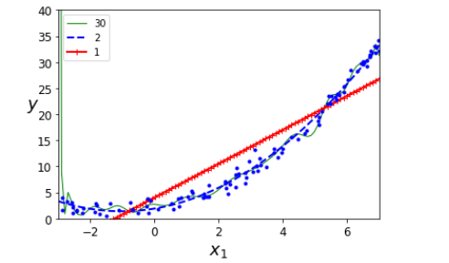

How well:

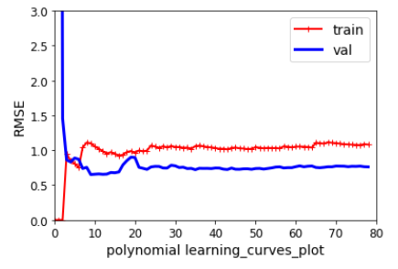

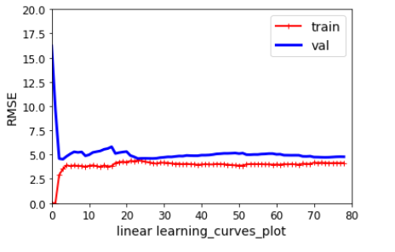

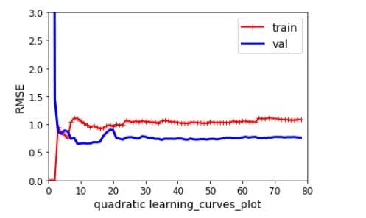

Linear model fits bad.

2.5 For ECE 450 students, briefly describe the five algorithms: stochastic gradient descent with L1 penalty, stochastic gradient descent with L2 penalty, ridge regression, LASSO regression, and elastic net.

stochastic gradient descent with L1 penalty,

stochastic gradient descent with L2 penalty,

ridge regression,

LASSO regression,

and elastic net

2.6. Work through the logistic regression and softmax regression examples. Explain how regression and classification are related.

**Lab Report and Submission: See report guideline for detailed requirements.**